Quotation No: Q-2026-019-R0
Date :- 12.03.2026



Kind Attn. : Mr. Avinash Gonge

Project : - Engine conveyor along with engine pallets

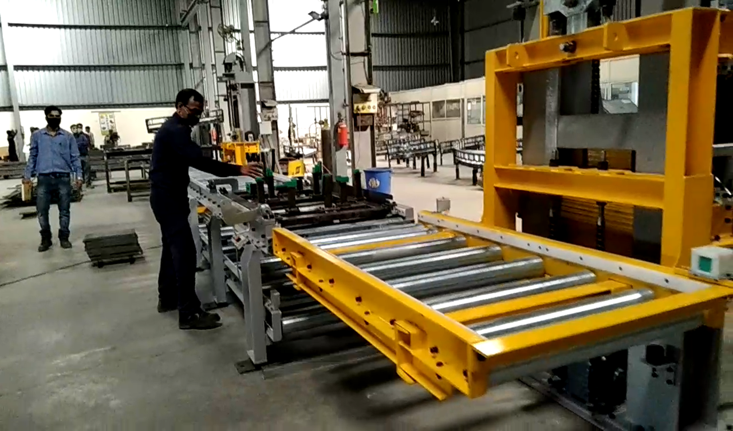
Prologic site installation photo

Contact person:-
Vijay Shete Dayanand Dalvi
Business Development M.D.
Cell No. : 7558222587 Cell No. 9881092586
vijayshete@prologicmechatronics.com dayananddalvi@prologicmechatronics.com
- Quotation Reference :
As per received RFQ on mail dated 12-02-2026 and subsequent visit & discussion regarding the Engine Conveyor along with engine pallet .

- RFQ details:

Sr No | Item | Reference
1 | PALLETISED ENGINE DRESSING CONVEYOR FOR 4SP/497 AND CUMMINS ENGINES AT D10. | Remarks
a | Top Chain Roller Powerised Conveyor and Bottom conveyor TI Diamond ( Triplex) Accumulator Chain. Floor Mounted Conveyor - Aluminum Extruded Section | 31.70 Meters
b | Electrically Operated Lifters | 2 Nos
c | Pallets for Engine Dressing with Kitting arrangement | 25 Nos
d | Pneumatic Stooper for Top and Return Conveyor | 19 Nos
e | PLC Siemens Make - 1500 Series | 1 No
f | HMI 15 inch compatible with Siemens make | 2 Nos
g | Hardware Boxes with mounting on conveyor ( Mat - SS 304 to be used ) | 32 Nos
h | Indeva Make Electrically operated Manipulator - 80 kg Capacity | 3 Nos
i | Demag Rail with hoist to be provided for gear box fitment | 2 Nos
j | Cognex Scanner - Model - DM8700 series bluetooth wireless | 16 Nos
k | IPC Details - IPC should be Advantech PPC 315 Fanless version. OS should be Windows 10 IOT 2021 LTSC.  Advantech make Latest Industrial PC with Software for storage of data against the Unique Serial number  Data should be captured in SQL Data base along with facility to retrieve and check data and trend on Advantech PC | 1 Set
l | ANDON System for display of Hold Station | 1 No
m | Fensing with Electrical Latch for both Lifter | 2 Nos
n | Interfacing for various Tools at TML site like SSNR , Battery Torque controlled tools and torque wrench with Blue tooth etc | Provision for 50 nos
o | Data acquisition based on scanning system at each station for component idenfications and data capturing for identified stations | 1 Set
p | Each station with 4 buttons for Conveyor stoppage ( Process , Quality , Equipment and Material) | 64 Nos

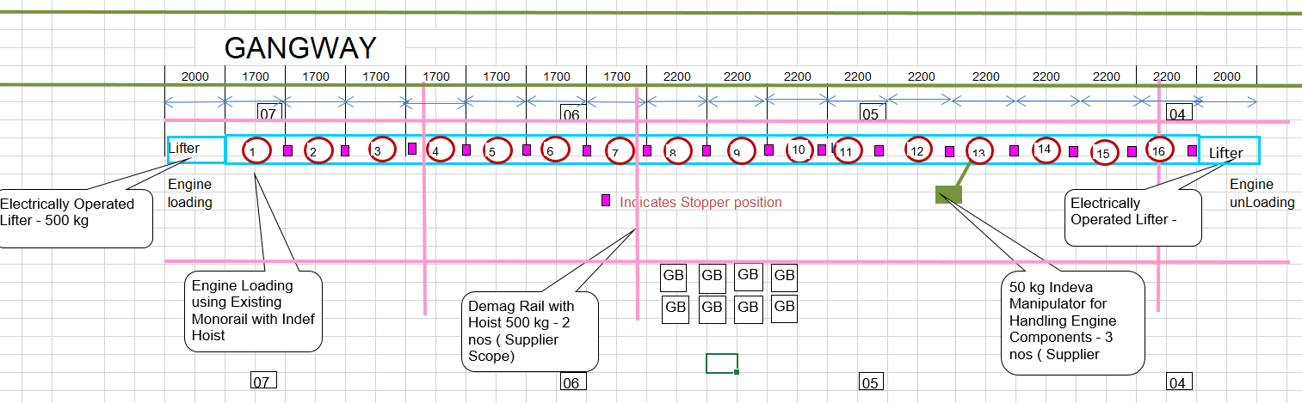

- PMPL scope of supply includes following activities:

- Concept discussion along with Tata Motors team.
- Preparation of layout and presenting the DAP drgs. for approval.
- Detail designing of all the mechanical & electrical equipment’s as per scope.
- Design, supply & installation of Accumulation chain conveyor with Lifters.
- Detail project planning as per committed timelines.
- Monitoring, reporting & control of all the activates to meet the timelines.
- Design of Control Panels in E-plan, and panel layouts & Cable routine in AutoCAD.
- Preparation of Complete Bill of Material
For Control Panels, Field Wiring, Software Development
- Site Wiring and Electrical Installation.
- Installation of mechanical and electrical equipment.
- Commissioning and debugging of the system.
- Training and documentation.

- ENGINE DRESSING LINE SCOPE:

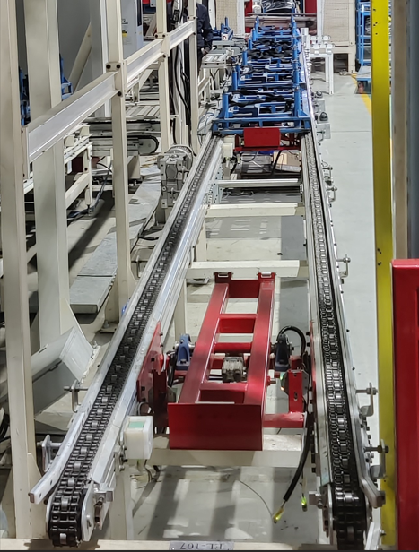
Accumulation Chain conveyor :

Ref photo of Accumulation chain conveyor
Specifications :

- Side members (LH+RH) – Al chain profile
- Chain Type – Triplex Accumulation chain (TIDC make)
- Chain Guide – MS profile
- MS leg supports
- Side guide – MS pipe
- Drive Geared motor with mounting arrangement

Vertical Lifter with roller conveyor (at both sides):

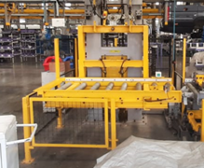
Ref photo of Lifter unit (Both sides)
Vertical Lift Specification :-
- H beam column mounted structure.
- X-Y Direction Guide roller arrangement for moving Frame
- Lifting Motor – Base mounted Gear box (Bharat Bijlee/Siemens Make)
- Two Chain lifting arrangement
- Lift stroke: - min. 800 mm
- Sensors are considered at up/down position
- Roller conveyor (2 mtr L)
- Required cabling ducting etc
- Fencing two sides is considered for lifts

Engine Pallet scope : 25 nos.
- Design of the pallet as per suitable engine supporting pegs/ fixture
- Pallet size : 1200mm x 1000mm Aprox
- Quantity : 25 nos of pallets are considered
- Collabsible (manual) resting is considered (detailing during DAP)
- Swivelling arrangement
- Tool box Tray
- Bottom side Friction pads are considered
Note :

Tata Motors to provide the detail drawing for engine transmission with resting point confirmation for design of the pallet resting points

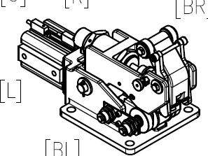
Stopper unit : (FESTO Make) 19 Nos.
Compact Cylinder : KADVB-50-50-P-A-S – FESTO
Stopper : DHDB-50-50-P-A-H-L-BL-N – FESTO
With Sol. Valve, fitting & Pneumatic tubing

Pneumatically actuated Pallet stopper unit will be mounted on fixed member beteen the Accumilation chain at required interval.
It is used to stop and accumulate the pallet on the Chain conveyor without stopping the drive moter. And another pallet could be loaded and forwarded in-a- row as per requirement.

Floor Column Mounted Indeva Make Electric Servo Balancer : 3 Nos.
1 - LIFTRONIC-EASY E80CH3.0
- INTELLIGENT DEVICE FOR HANDLING INDEVA® mod. LIFTRONIC® EASY VERSION 6 Type of manipulator:
- ARM ON COLUMN HEAVY SIZE The system is composed of:
- ELECTRONIC LOAD BALANCER with the following technical features:
- E80CH3,0 - max. load capacity: 80 Kg - net capacity: 60 Kg
- number of ropes: 1 - rope extension metal chain: not present
- upper position control: present - standard lift stroke: 2800 mm
- motor locking system on Z axis: not present
- endless swivel joint for gripping tooling: present - max. lift speed: 36.0 m/min
- power supply: 230 V - 50/60 Hz - max. power consumption: 700 W
- protection degree: IP 54 ORBIT-ARM - TWO JOINTS (std)
- arm length 3.0 m; - maximum rotation around the vertical axis of 360°
- column mounting flange - clutches (adjustable by means of set screws) installed on both arm joints COLUMN height 2.40 m for Orbit-Arm support complete with mounting flange to anchor it to the floor EASY HEAD
- MODEL COMPACT - for taking the load, equipped with the following standard components: - ELECTRONIC SYSTEM FOR AUTOMATIC SELF-BALANCING of the load;
- TOUCH SCREEN simple and intuitive for displaying the manipulator; operating parameters; - USB-PC CONNECTOR for communication between manipulator and PC;
- PREDISPOSITION for MECHANICAL CONNECTIONS for the application of any remote handles; - "STOP" BUTTON to stop the "up" and "down" movement; - "FLOAT-MODE" BUTTON for storing the weight of the lifted load, enabling to choose to handle the load directly;
- PREDISPOSITION for adding two buttons to manage the customer's tool or to manage "up" and "down" movement;
- STANDARD HOOK with safety clip; The HEAD is equipped with the following accessories:

REMOTE METALLIC SINGLE HANDLE ( to be mounted on CUSTOMER TOOLING ) application at customer's charge Inline

SENSITIVE HANDLE - VERTICAL model - L= mm 250 that increases smoothness in the load picking/release phases (In particular, it increases the balancer sensitivity in all handling phases of about 80% and consequently speeds up work pace) Complete with cable 1000 mm long, with a plug for the outlet on the side of the control head.

STANDARD PAINTING: GREEN RAL 6018
CHEMICAL Anchor BOLTS – 4 Nos

Electrical Scope of Supply (for Conveyor) :
- Comon electrical control panel assembly for Conveyor
- Installation and connection of Main control panel and field cables
- Commissioning of system
Sr. No. | Description | Quantity
1 | Main Control Panel | 1No
2 | HMI (15”) | 2No’s
3 | Sensors | 1Set
4 | Field Cables | 1Set
5 | Field Cable Trays | 1Set
6 | Field Materials | 1Set
7 | Operator Boxes | 1Set
8 | Junction Boxes | 1Set
9 | Software Development | Included
10 | Project Management | Included
11 | Site Supervision | Included
12 | Site Installation | Included
13 | Commissioning | Included
14 | Production Support | Included
15 | Encoder | Not Included
16 | Barcode Reader | Not Included
17 | RFID Reader | Not Included
18 | Wireless Communication – Rcoax cable | Not Required
19 | Barcode Tape | Not Required
20 | Light Curtain | Not Included
21 | Area Scanner | Not Included
22 | Handheld Barcode Scanner | 16No’s

Make of Bought out Items:
Sr. No. | Description | Make | Supply from Prologic | Remark
1 | PLC S71500 CPU1515-3PN | Siemens | √
2 | RIO Module – ET200SP | Siemens | √
3 | Unmanaged Switch 8port | Siemens | √
4 | VFD G120 | Siemens | √
5 | HMI TP15” Comfort | Siemens | √ | 2No’s
6 | SMPS 24VDC, 5A, 10A | Siemens | √
7 | Choke | Sahara | √
8 | Transformer | Sahara | √
9 | Switchgears | Siemens / Schneider | √ | MCB, OLR, Contactors Etc...
10 | Control Panel & Boxes | Rittal / Local | √ | PS Series, IP55
11 | Panel AC | Rittal | √
12 | Push Button, Indication lamp & Selector Switch, Etc... | Teknic / Schneider | √
13 | Limit Switch | Omron / Teknic | √
14 | Sensor | IFM / Teknic | √ | Photo Sensor, Proximity
15 | Sensor Cables | IFM | √ | Standard cable
16 | Relay Module | Omron / Phoenix | √
17 | Panel Internal Flexible PVC cables | Lapp | √
18 | All C class Items for Control Panels | Reputed | √
19 | Field Power and Multicore control cables non-Armoured | Lapp | √ | Power, Control
20 | Cable Tray's and its accessories | Local | √
21 | Terminals | Wago | √ | Control panel and JB
22 | Tower Lamp with Buzzer | Patlite | √
23 | Revolving Lamp | DSS | -
24 | Main incoming Power cable | Polycab | - | Not Included
25 | Encoder | Omron | - | Not Required
26 | Handheld Barcode Scanner | Cognex | √ | 16No’s DM 8700
27 | RFID Reader | Siemens | - | Not Required
28 | Wireless System | Siemens | - | Not Required
29 | Communication Cable | Lapp / Siemens | √ | Non pre-molded
30 | Light Curtain | Sick | - | Not Included
31 | Door safety switch | Euchner | √ | Included
32 | IPC 15.6" PPC w/ i7-1365UE P-Cap, Windows 10 IOT 2021 LTSC, 512GB SSD, 16GB DDR4 RAM | Advantech | √ | PPC-315SW-PDI7A

Few references for systems installed by Prologic Mechatronics Pvt. Ltd.

PSA Citroen, Chennai, India
PRBs , Lifts , Geo skids, metal finish line , EMS systems for car body & empty skids, Pop up cross transfer conveyors etc.

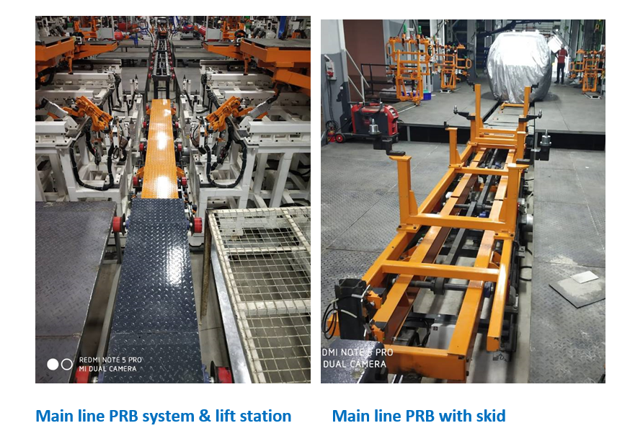


Maxion Wheels Ltd , Chakan ( India )
Turn key floor conveyor system for Alloy wheel manufacturing.
Total Roller & belt conveyor length of @ 700 mtrs with tact time of 9 secs.

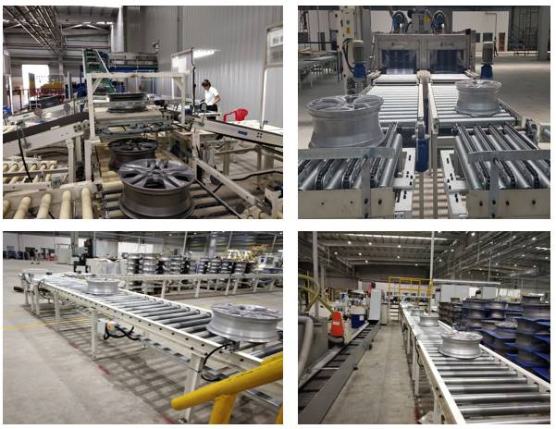


FIAT Ltd, Ranjangaon Pune ( India )
Roller conveyor with Turnover device
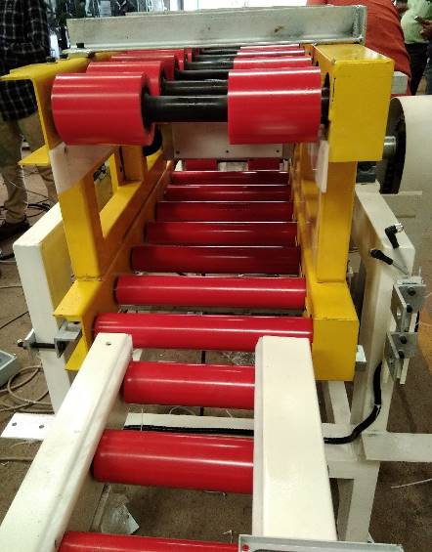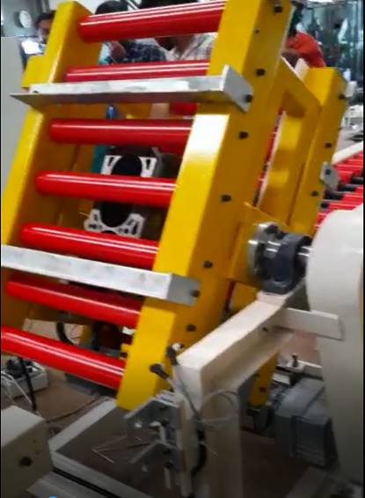

- ASRS and storage
  - BIW storage
  - Painted body storage
  - Engine storage

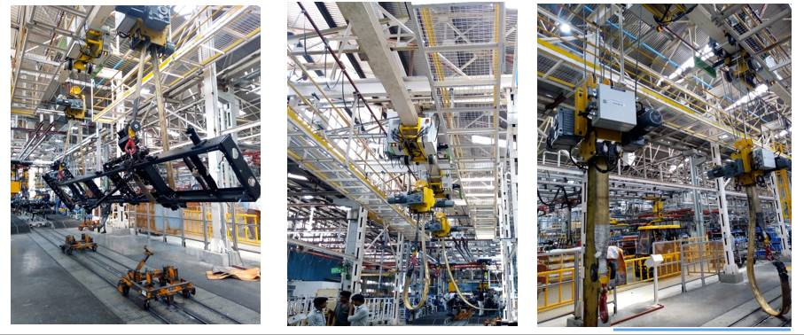
BIW Paint Shop Buffer Line at PSA, Chennai

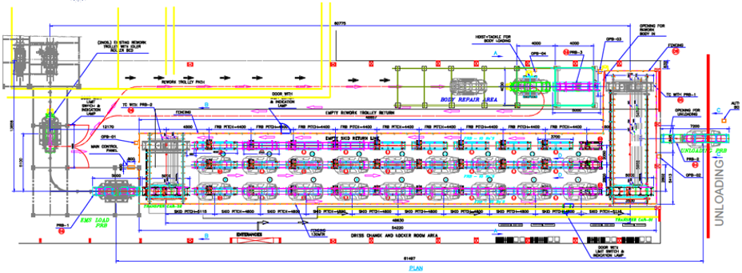

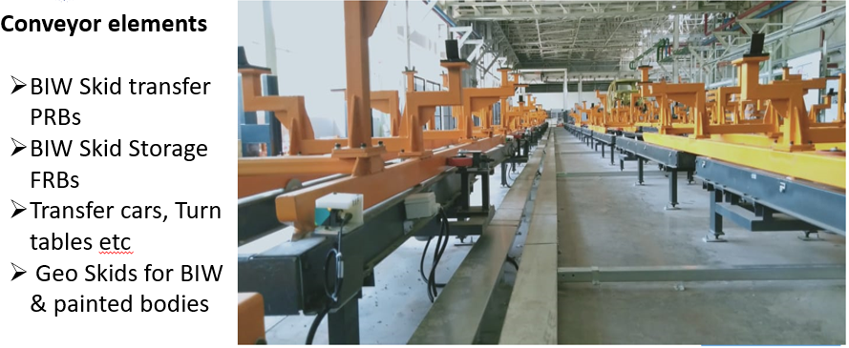

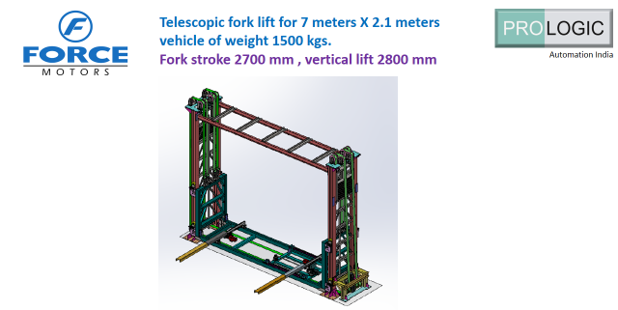

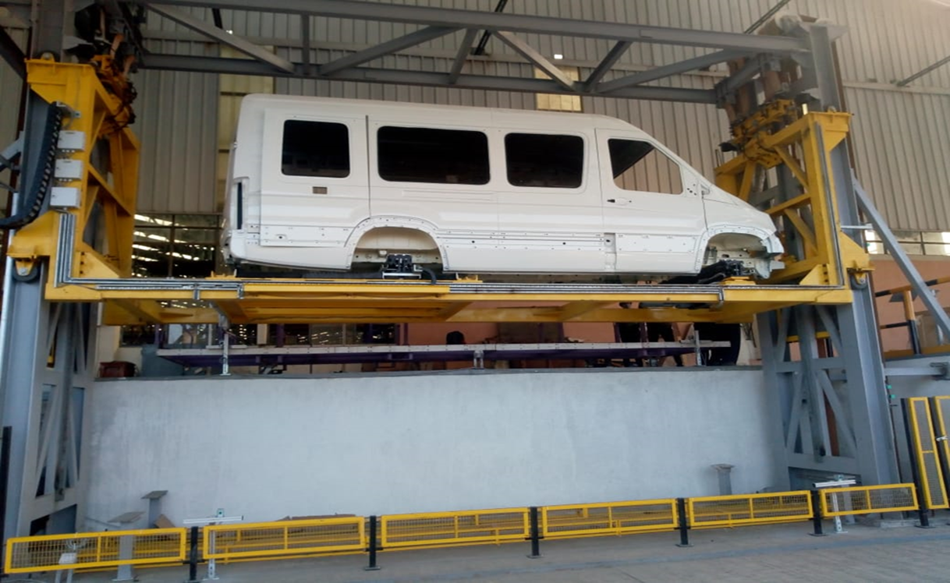


Roller conveyors with end lifter for
Power pack – Engine with transmission
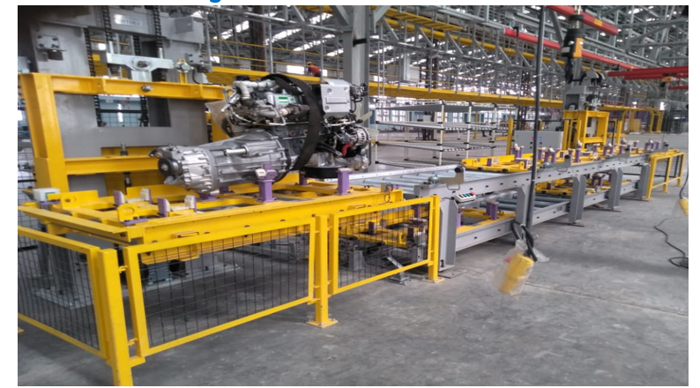
Our manufacturing Factory
At Pune India
Area 20,000 sq. ft. with CNC profile cutting machine ,
Milling machine , band saw machine ,
Lathe and drilling machines ,
Along with 5t & 2t Cranes
Our Major customers
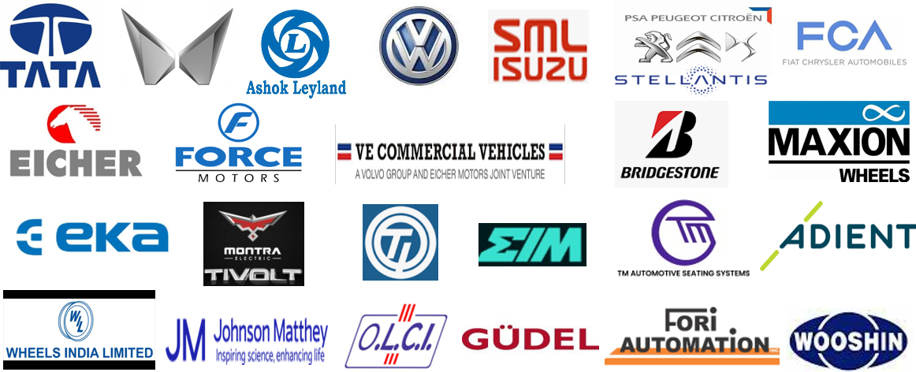

Not in scope of supply:

- All Civil scope (except as mentioned in proposal)
- Acceptance tests or legal approvals by any 3rd party or institution
- Modification of existing structure.
- Electrical and pneumatic supply for installation
- Electrical safety devices not mentioned in this offer
- Light curtains area scanners, safety gate switches which are not specifically mentioned in the offer
- Interfacing signals of customers’ existing or new equipment which are not part of our scope, signals from equipment not in scope but needed
- Process air supply and valves
- IT – Cabling (Networks in higher level)
- Production assistance or standby other than mentioned in offer.
- Incoming Supply to Main & RIO Control panel
- Electrical & Instrument Earth
- Third party Network certification
- Third Party Interfacing
- Conveyors required at expansion time

General T/C Sheet

Safety
  - Specific safety requirements in case of any mechanical, chemical, fire Hazard during installation, commissioning or running of equipment or line will be mentioned
  - Responsibility of safety, use of PPE, ESI, PF, etc. of Supplier site team member and other sub −contractor
  - Test certificates & Safety sign for supplied facilities will be provided.

Customer Training
  - Operation & Maintenance training, off−field and On−field training
  - Production training to operator for smooth operation.
  - Theoretical & practical operation & maintenance training of any special equipment. All the communication and documentation in English language.

Technical assistance
  - We will ensure trained and qualified Engineers and technicians and the duration of time or execution of project with all its phases at site.
  - Our team will provide necessary supports during pre −production and ramp up phases of production for the time duration mentioned in the offer.

Documentation / Test Certificates
Documentation in Hardcopy format (3nos. each) and Softcopy (01 no. external hard disk) of all the followings documentsƒdrawings (It should be in English only)
  - Layout for presentation (movie view file)
  - Work instruction & OS (Operating standard) for complete process flow.
  - 2d drawing (Auto Cad & Pdf) of all manufacturing items main assemblies ( not part drgs )
  - Electrical & Pneumatic Circuits drawing in hard copy & softcopy.
  - Operational Manual, Technical Spare Parts List & specifications
  - Maintenance Manual & PM Schedules
  - Station wise equipment list, details
  - PLC, HMI backup
  - Warranty & Test certificate

Warranty & post installation support
Warranty 12 months from date of supply.
Up time : 98% for 3 shift working

Commercial Scope :
Sr No. | Description | Qty. | Total Price (INR)
1 | Top Chain Roller Powerised Conveyor and Bottom conveyor TI Diamond ( Triplex) Accumulator Chain. Floor Mounted Conveyor - Aluminum Extruded Section | 1 No. | 3,66,97,840
2 | Electrically Operated Lifters | 2 Nos. | 3,66,97,840
3 | Pallets for Engine Dressing with Kitting arrangement | 25 Nos. | 3,66,97,840
4 | Pneumatic Stooper for Top and Return Conveyor | 19 Nos. | 3,66,97,840
5 | Indeva Make Electrically operated Manipulator - 80 kg Capacity | 3 Nos. | 84,02,550
6 | Demag Rail with hoist to be provided for gear box fitment | 2 Nos. | 46,29,000
7 | Electrical & Controls | 1 Set | 1,09,36,680
8 | ANDON System | 1 Set | 10,44,000
9 | Packing, Forwarding & Freight | 1 Set | 1,46,250
10 | Installation & commissioning of Engine Conveyor system | 1 Set | 7,99,000
 | Total Commercial Scope (INR) |  | 6,26,55,320

- Delivery: At Tata Motors, J Block, Pune within 18 - 20 Week after DAP.

- Taxes and duties: All taxes, duties and Insurance levied from time to time by statutory authorities are not included and are additional.

- Payment terms :
Supply payment terms:
- 20% advance payment with the order
- 10% after DAP approval
- 60% +100% taxes against delivery each invoice (i.e. Pro-rata Basis)
- 10% after installation
Installation payment terms:
- 50% Advance against mobilisation of site for dismantling & installation
- 50% against successful installation & commissioning

- Validity of Offer: One Month
If you have any questions please do not hesitate to contact us.
Thanks and best regards,

Dayanand Dalvi
Managing Director

